**Digital Circuits and Simulation**

**Deeds:** [**https://www.digitalelectronicsdeeds.com/downloads.html**](https://www.digitalelectronicsdeeds.com/downloads.html)

**Exercise 1 -** Fill the truth tables and simulate using DEEDS in order to verify the truth tables

|  |  |
| --- | --- |
| **A** | **OUT** |
|  |  |
|  |  |

|  |  |  |
| --- | --- | --- |
| **A** | **B** | **OUT** |
|  |  |  |
|  |  |  |
|  |  |  |
|  |  |  |

a) 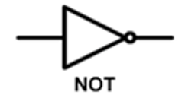

|  |  |  |
| --- | --- | --- |
| **A** | **B** | **OUT** |
|  |  |  |
|  |  |  |
|  |  |  |
|  |  |  |

|  |  |  |
| --- | --- | --- |
| **A** | **B** | **OUT** |
|  |  |  |
|  |  |  |
|  |  |  |
|  |  |  |

c)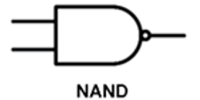 d) 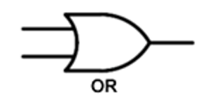

|  |  |  |
| --- | --- | --- |
| **A** | **B** | **OUT** |
|  |  |  |
|  |  |  |
|  |  |  |
|  |  |  |

|  |  |  |
| --- | --- | --- |
| **A** | **B** | **OUT** |
|  |  |  |
|  |  |  |
|  |  |  |
|  |  |  |

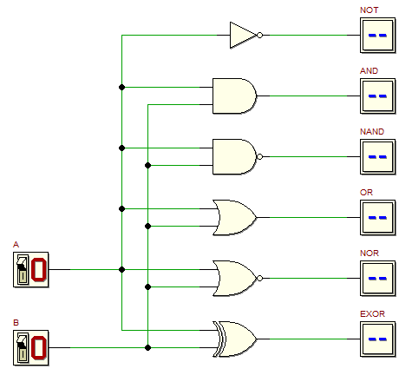

**Exercise 2** - Fill the truth table and the time diagram; then design the circuit using DEEDS to check the correctness of your answers

|  |  |  |  |
| --- | --- | --- | --- |
| **A** | **B** | **C** | **OUT** |
|  |  |  |  |
|  |  |  |  |
|  |  |  |  |
|  |  |  |  |
|  |  |  |  |
|  |  |  |  |
|  |  |  |  |
|  |  |  |  |

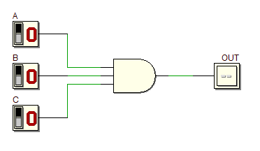

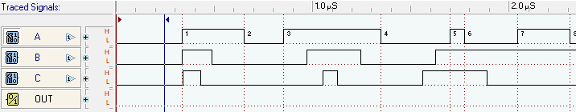

**Exercise 3** - Fill the truth table and the time diagram; then design the circuit using DEEDS to check the correctness of your answers

|  |  |  |  |
| --- | --- | --- | --- |
| **A** | **B** | **C** | **OUT** |
|  |  |  |  |
|  |  |  |  |
|  |  |  |  |
|  |  |  |  |
|  |  |  |  |
|  |  |  |  |
|  |  |  |  |
|  |  |  |  |

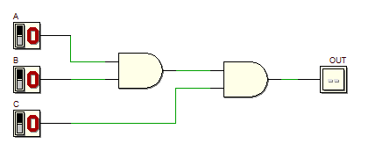



|  |  |  |  |
| --- | --- | --- | --- |
| **A** | **B** | **C** | **OUT** |
|  |  |  |  |
|  |  |  |  |
|  |  |  |  |
|  |  |  |  |
|  |  |  |  |
|  |  |  |  |
|  |  |  |  |
|  |  |  |  |

**Exercise 4** - Fill the truth table and the time diagram; then design the circuit using DEEDS to check the correctness of your answers

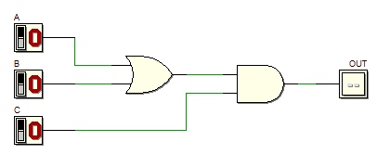



|  |  |  |  |
| --- | --- | --- | --- |
| **A** | **B** | **C** | **OUT** |
|  |  |  |  |
|  |  |  |  |
|  |  |  |  |
|  |  |  |  |
|  |  |  |  |
|  |  |  |  |
|  |  |  |  |
|  |  |  |  |

**Exercise 5** - Fill the truth table and the time diagram; then design the circuit using DEEDS to check the correctness of your answers

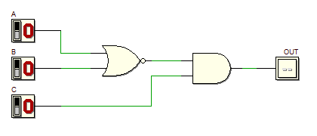



**Exercise 6** - Fill the truth table and the time diagram; then design the circuit using DEEDS to check the correctness of your answers. This is a three-input OR-AND-INVERT gate, it produces FALSE if C is TRUE and A or B is TRUE, otherwise it produces TRUE.

|  |  |  |  |
| --- | --- | --- | --- |
| **A** | **B** | **C** | **OUT** |
|  |  |  |  |
|  |  |  |  |
|  |  |  |  |
|  |  |  |  |
|  |  |  |  |
|  |  |  |  |
|  |  |  |  |
|  |  |  |  |

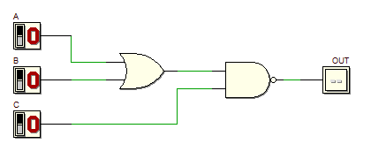



|  |  |  |  |
| --- | --- | --- | --- |
| **A** | **B** | **C** | **OUT** |
|  |  |  |  |
|  |  |  |  |
|  |  |  |  |
|  |  |  |  |
|  |  |  |  |
|  |  |  |  |
|  |  |  |  |
|  |  |  |  |

**Exercise 7** - Fill the truth table and the time diagram; then design the circuit using DEEDS to check the correctness of your answers

**Exercise 8** - Fill the truth table and the time diagram; then design the circuit using DEEDS to check the correctness of your answers

|  |  |  |  |  |
| --- | --- | --- | --- | --- |
| **A** | **B** | **C** | **D** | **OUT** |
|  |  |  |  |  |
|  |  |  |  |  |
|  |  |  |  |  |
|  |  |  |  |  |
|  |  |  |  |  |
|  |  |  |  |  |
|  |  |  |  |  |
|  |  |  |  |  |
|  |  |  |  |  |
|  |  |  |  |  |
|  |  |  |  |  |
|  |  |  |  |  |
|  |  |  |  |  |
|  |  |  |  |  |
|  |  |  |  |  |
|  |  |  |  |  |

**Exercise 9** - Fill the truth table and the time diagram; then design the circuit using DEEDS to check the correctness of your answers

|  |  |  |  |  |
| --- | --- | --- | --- | --- |
| **A** | **B** | **C** | **D** | **OUT** |
|  |  |  |  |  |
|  |  |  |  |  |
|  |  |  |  |  |
|  |  |  |  |  |
|  |  |  |  |  |
|  |  |  |  |  |
|  |  |  |  |  |
|  |  |  |  |  |
|  |  |  |  |  |
|  |  |  |  |  |
|  |  |  |  |  |
|  |  |  |  |  |
|  |  |  |  |  |
|  |  |  |  |  |
|  |  |  |  |  |
|  |  |  |  |  |

**Exercise 10** - Fill the truth table and the time diagram; then design the circuit using DEEDS to check the correctness of your answers

|  |  |  |  |  |
| --- | --- | --- | --- | --- |
| **A** | **B** | **C** | **D** | **OUT** |
|  |  |  |  |  |
|  |  |  |  |  |
|  |  |  |  |  |
|  |  |  |  |  |
|  |  |  |  |  |
|  |  |  |  |  |
|  |  |  |  |  |
|  |  |  |  |  |
|  |  |  |  |  |
|  |  |  |  |  |
|  |  |  |  |  |
|  |  |  |  |  |
|  |  |  |  |  |
|  |  |  |  |  |
|  |  |  |  |  |
|  |  |  |  |  |

**Exercise 11** - Fill the truth table and the time diagram; then design the circuit using DEEDS to check the correctness of your answers

|  |  |  |  |  |
| --- | --- | --- | --- | --- |
| **A** | **B** | **C** | **D** | **OUT** |
|  |  |  |  |  |
|  |  |  |  |  |
|  |  |  |  |  |
|  |  |  |  |  |
|  |  |  |  |  |
|  |  |  |  |  |
|  |  |  |  |  |
|  |  |  |  |  |
|  |  |  |  |  |
|  |  |  |  |  |
|  |  |  |  |  |
|  |  |  |  |  |
|  |  |  |  |  |
|  |  |  |  |  |
|  |  |  |  |  |
|  |  |  |  |  |



